Lesson 06 Demo 02

Integrating Maven with Jenkins

Objective: To install the Maven plugin in Jenkins for smooth integration and automation of Maven-based build processes within the Jenkins environment

Tools required: Git, GitHub, and Jenkins

Prerequisites: None

Steps to be followed:
- Install the Maven plugin
- Set up Global Tool Configuration
- Fork a sample repository
- Integrate Maven with Jenkins

Step 1: Install the Maven plugin

- Open the browser, go to the Jenkins Dashboard by typing localhost:8080 in your browser, provide the credentials, and click the Sign in button



- Click on the Manage Jenkins option as shown in the screenshot below:
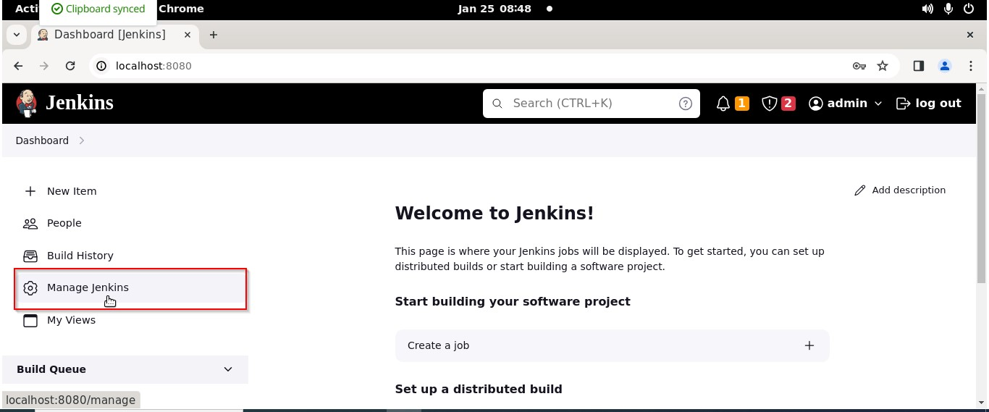

- Click on the Plugins option as shown in the screenshot below:
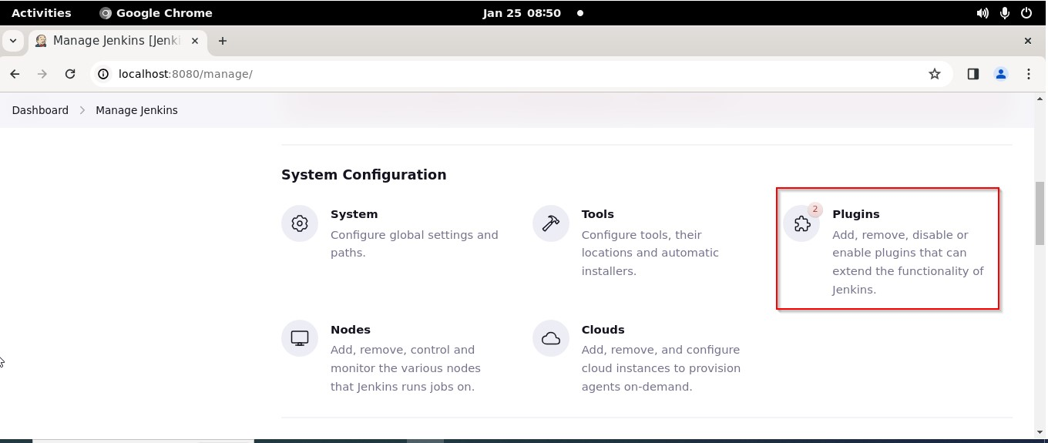

- Click on Installed plugins to verify whether the Maven Integration plugin has been installed

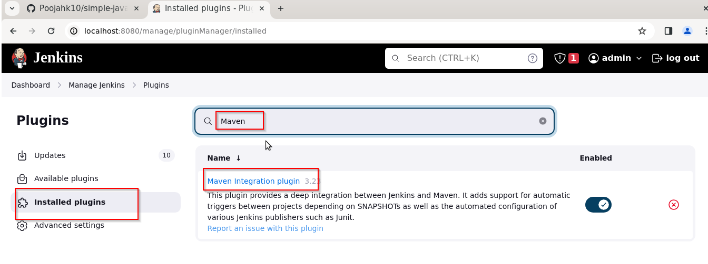

Note: Maven is already installed in your practice lab environment. If not, click on Available plugins, search for the Maven Integration plugin, and install it.

Step 2: Set up Global Tool Configuration

- Go to the Jenkins Dashboard, click on Manage Jenkins, and then select Tools from the list of options

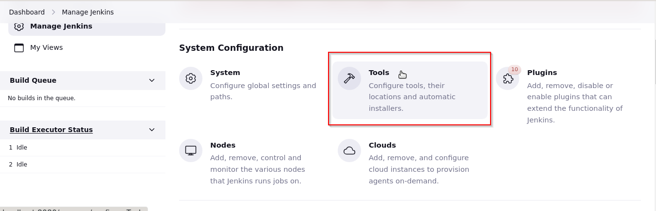

- Click on JDK installations and provide the Name and JAVA_HOME path

Note: Set the JAVA_HOME environment variable to /usr/lib/jvm/java-11-openjdk-amd64
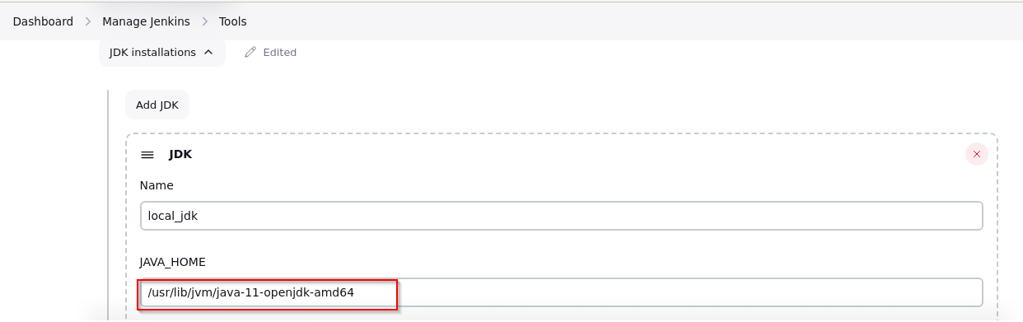

- To configure Maven, click on the Maven installations button in the Maven section and enter a Name and MAVEN_HOME path

Note: Set the MAVEN_HOME environment variable to /usr/share/maven

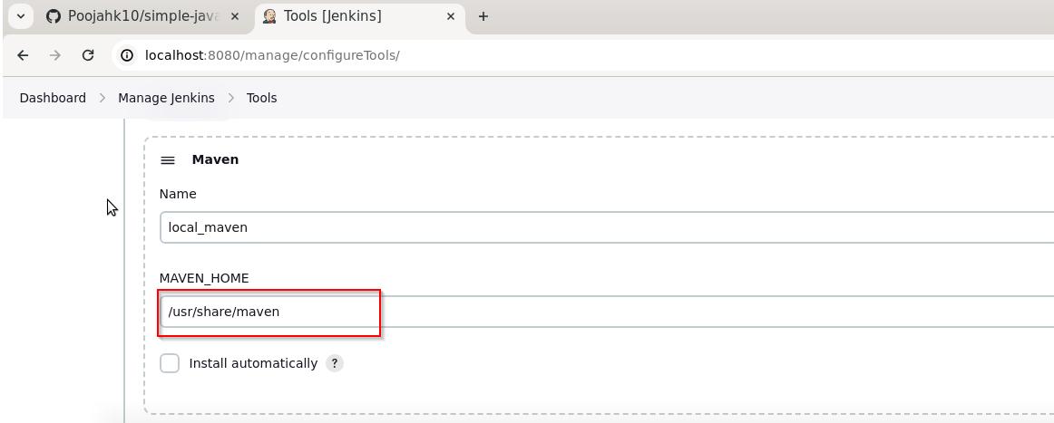

- To configure Git, click on Git installations and add the Name and Path to Git executable

Note: Set the Path to Git executable environment variable to /bin/git and click on Save

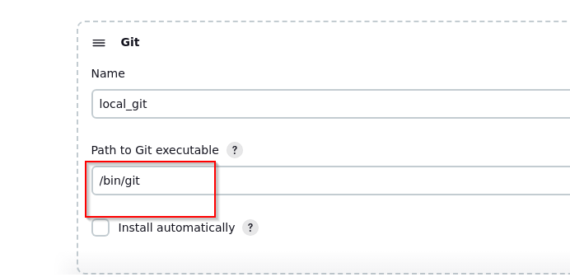

Step 3: Fork a sample repository

- Log in to your GitHub account, navigate to https://github.com/jenkins-docs/simple-java-maven-app, and click on Fork

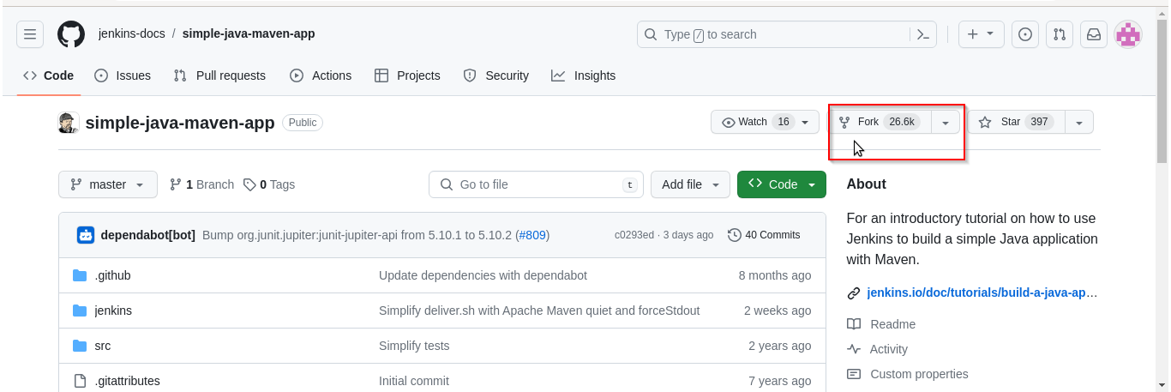

- Run git clone [Forked REPO URL] in the terminal to clone the repository locally

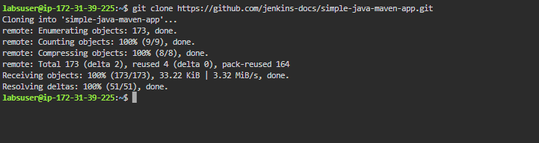

Step 4: Integrate Maven with Jenkins

- Click on New Item in the Jenkins Dashboard

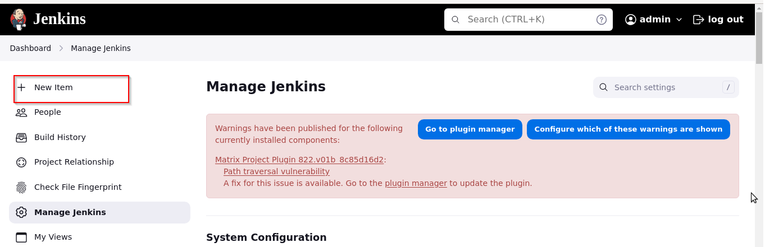

- Enter a name for the project, select Freestyle project as the build job type, and click on the OK button as shown in the screenshot below:

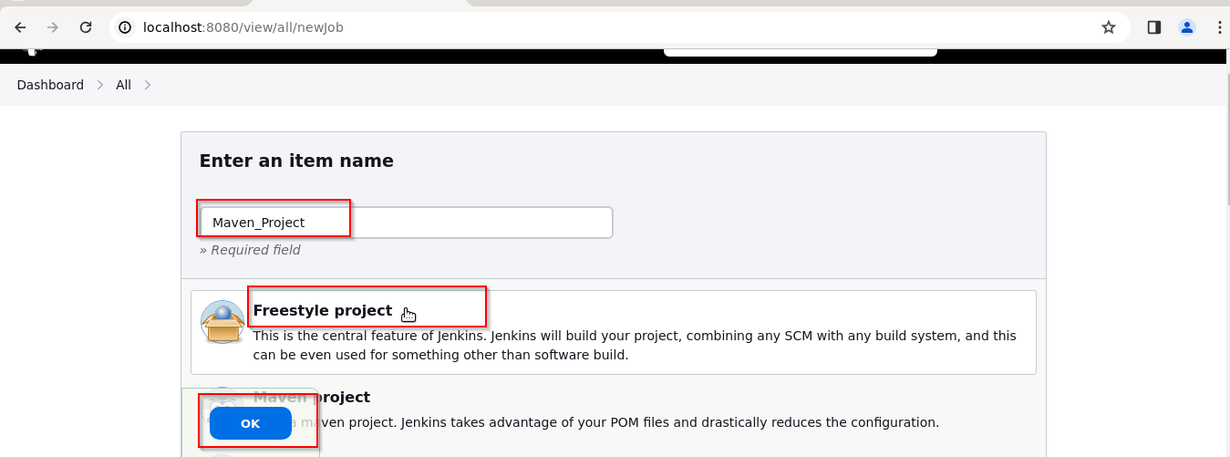

- Click on Source Code Management

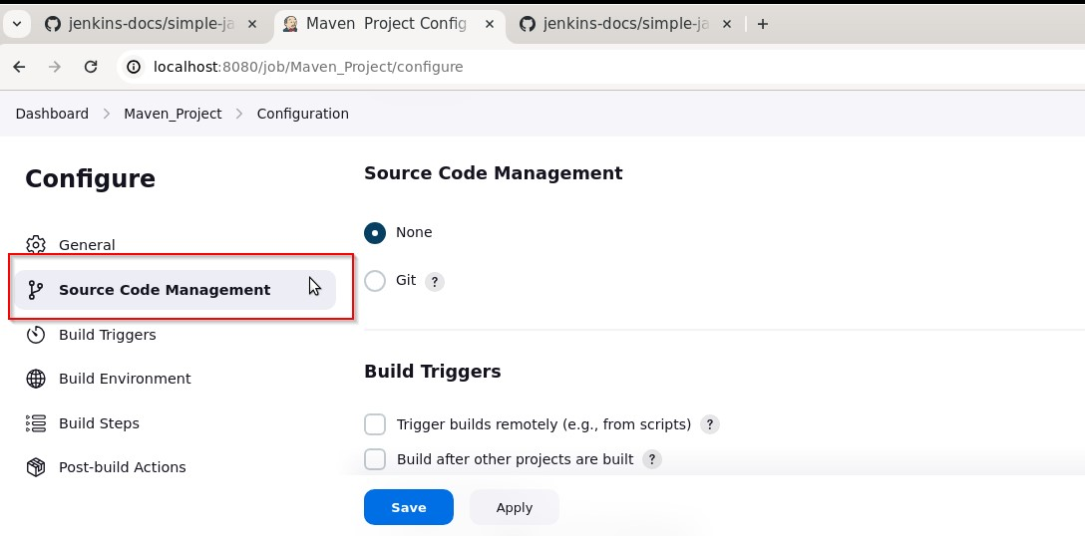

- Select Git and enter the Repository URL

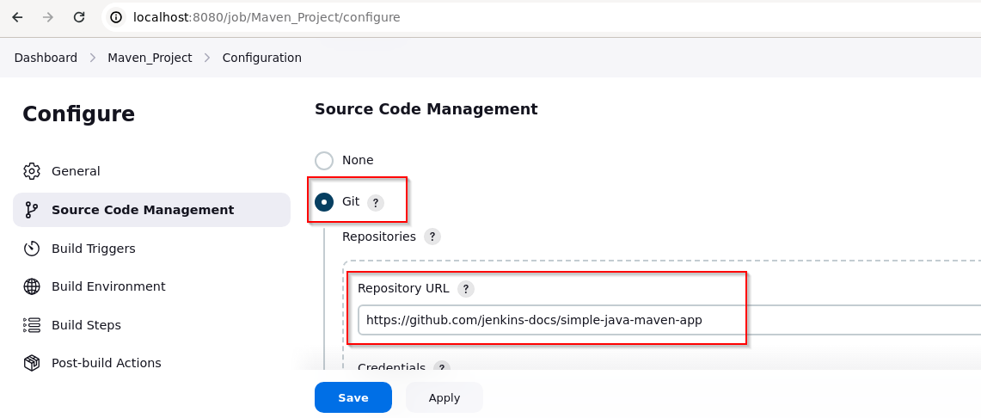

- Click on Build Triggers, select the required option as shown in the screenshot below, and then click on Save
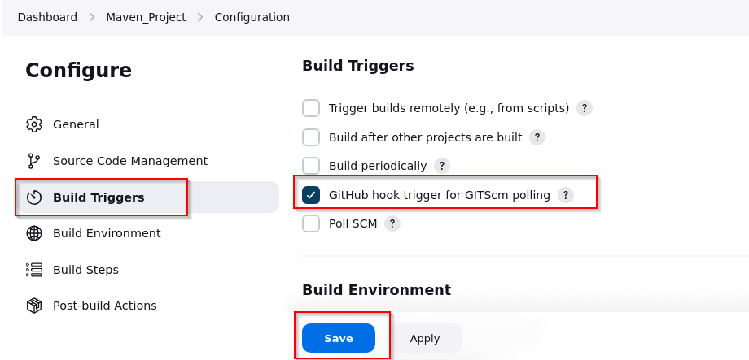

- Click on Build Now to view the build results

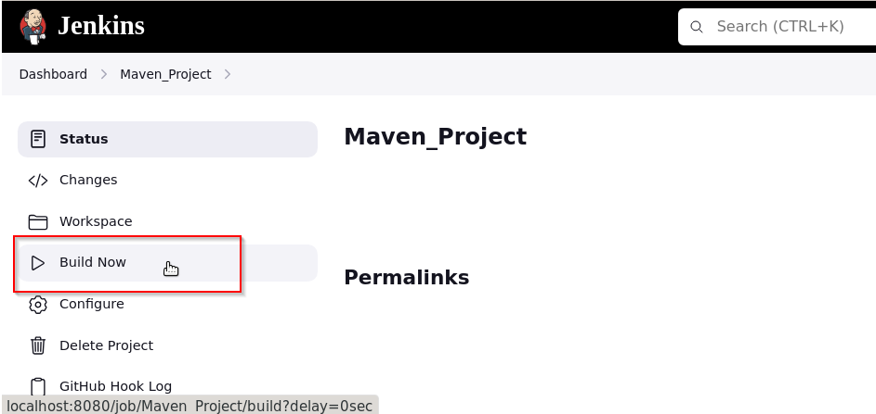

- Click on trend in the Build History as shown in the screenshot below:

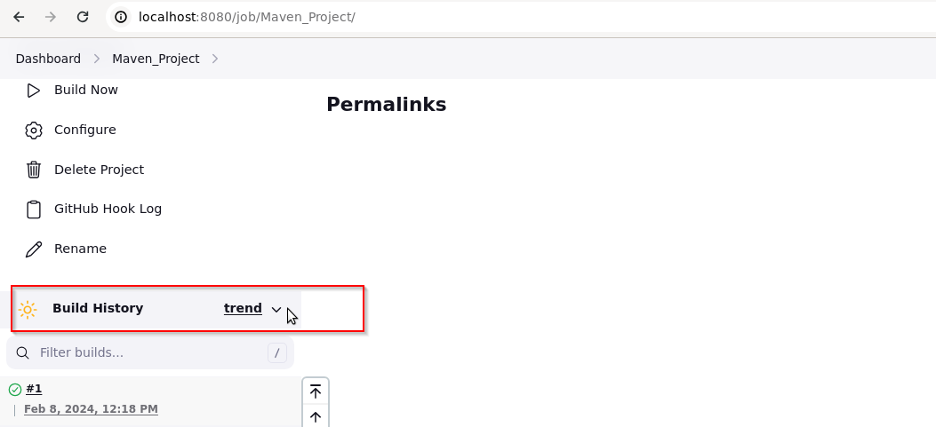

- Click on Status to view the build logs

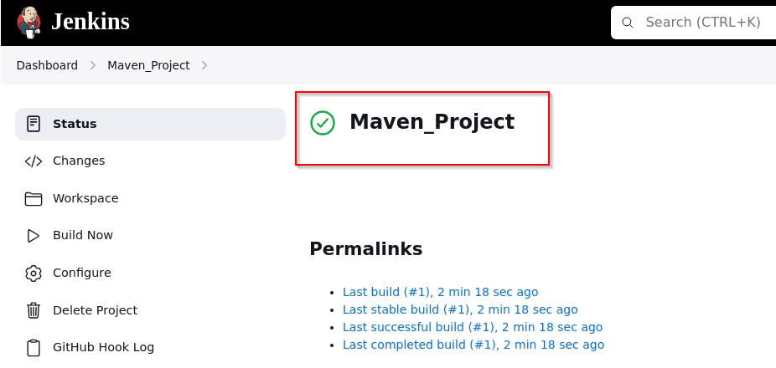

By following these steps, you have successfully installed the Maven plugin in Jenkins, making it easier to automate Maven-based build tasks within the Jenkins environment for smoother integration and workflow automation.

